HOLIDAY HOMEWORK
Class – 3
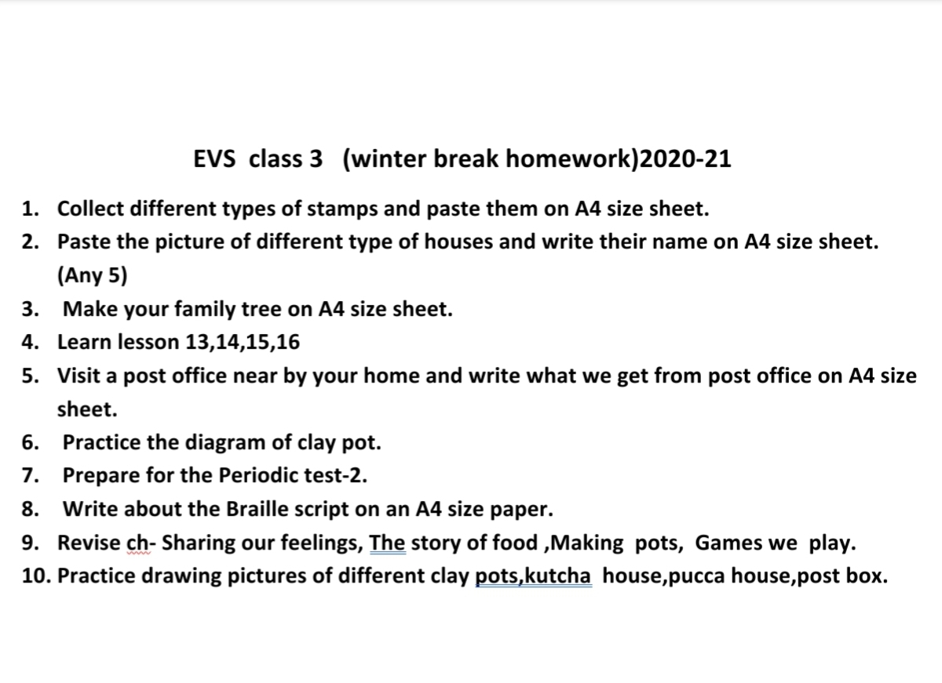
Subject- English
1.Write 5 sentences about Christmas.
2.write 25 antonyms.
3. Write 25 synonyms.
4. Write unit 8 in your notebook.
5. Learn all the questions and answers.
6. Write the names of tiger projects in India.

Hindi Holidays homework
1. आ,इ ,ई ,उ,ऊ की मात्रा वाले 10-10 शब्द लिखो ।
2. 10 पृष्ठ सुलेख के लिखना।
Math holidays homework
1. Make model of different types of balance (math textbook page 121).

